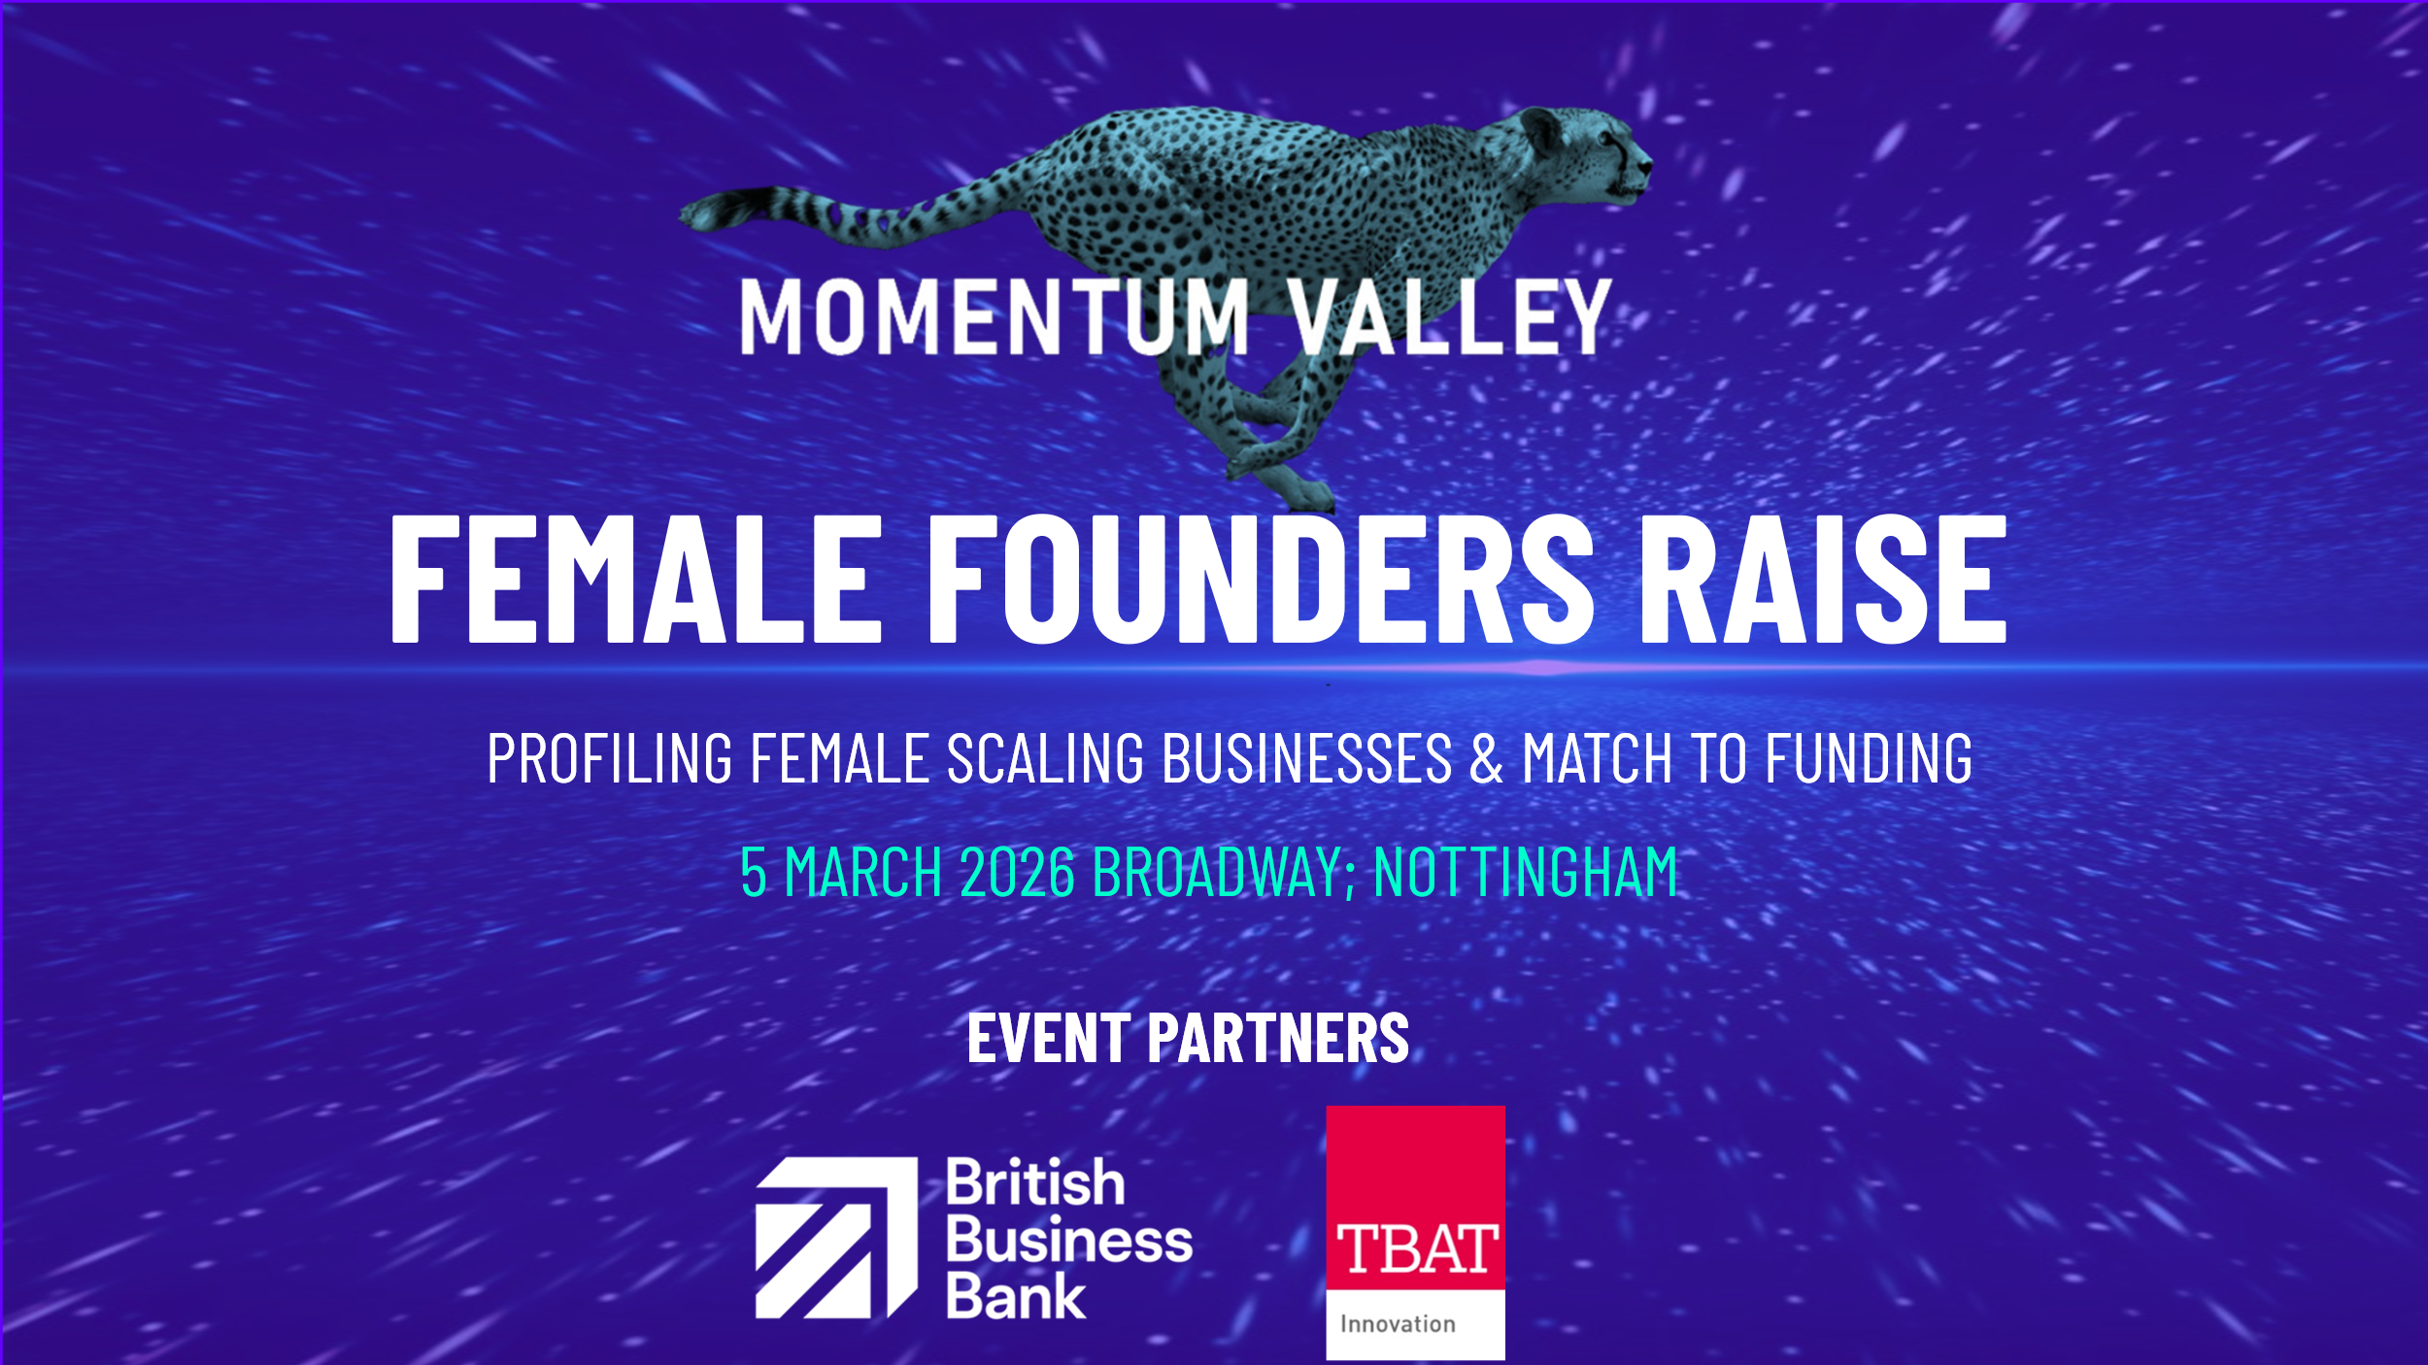

MOMENTUM VALLEY: FEMALE FOUNDERS RAISE
MOST VALUABLE PITCH participant application form
Our goals from the information provided:
● Brief enough for completion in under 10 minutes
● Comprehensive enough to give us real insight into the applicants and their businesses
● A mix of quant & qual data and insights

Introduction
Thank you for your interest in the Most Valuable Pitch competition as part of Female Founders Raise. This initiative is designed to support founders who are preparing to raise investment and want to strengthen their strategy, confidence, and investor readiness.
The application form should take no more than 10 minutes to complete. Your responses will help us understand you, your business, and where you are on your investment journey.
Please answer honestly - there are no right or wrong answers. All information you share will be treated as confidential and used only for the purposes of programme selection and reporting (in anonymised form).
Before you begin: You will be asked about yourself, your business, and your funding goals. You can save and return later if needed.

Section 1: Personal & Demographic Information
We ask the following questions to help us understand who is applying to take part in this programme and to ensure that our work is inclusive, equitable, and accessible.
Collecting demographic information allows us to:
● Monitor and improve representation across our programmes;
● Identify where additional outreach or support may be needed; and
● Report on participation trends in an anonymised and responsible way.
Your responses are confidential and will not affect the outcome of your application. You are welcome to select “Prefer not to say” for any question you would rather not answer.
Your full Name:
Email Address:
Telephone:
Location / Region:
Gender: “Prefer not to say” option
Ethnicity: + “Prefer not to say” option
Age Range: Under 25 / 25–34 / 35–44 / 45–54 / 55+ “Prefer not to say” option
Please advice if you have any accessibility or learning requirements that we can assist you with:

Section 2: Business Information
We would love to learn a bit more about your business and where you are on your journey.
- Business Name:
- Business Website:
- Social Media Handle:
- Sector / Industry:
- Stage of Business: Idea / Pre-Revenue / Post-Revenue / Scaling / Other:
- Number of Years Operating:
- Number of Employees (including founders):
Section 3: Funding & Growth
This section helps us understand your funding goals and where you are in your investment journey. There’s no “right” answer here - we are interested in your current plans and challenges, not how far along you are.

- Have you raised external investment previously?
(Yes/No – if yes, ask: how much and from what source?)

2. Why are you planning on raising investment (what business growth goals do you want your investment round to enable)? (short paragraph – 100 words max)

- How much do you plan to raise, and by when?

- What (if anything) is getting in the way of you raising investment? Is there any support you are hoping to receive through this training programme? (100 words max)

Section 4: Vision & Motivation
We would love to hear about your aspirations and what motivates you as a founder. This helps us understand the bigger picture behind your business and what success looks like for you.

What is your aspiration for your business over the next 3–5 years? (150 words max)

Optional Extras
What do you hope to gain from participating in this investment training programme?

How did you hear about this opportunity?

Application done! Great job.
Thank you for completing your application.
We appreciate the time you have taken to tell us about your business and investment goals. All applicants will be contacted once the selection process is complete.

If you have any questions about the programme or your application, please contact: ffrmv@hollandalexander.com.

We look forward to learning more about your journey and hopefully working with you in the programme.
Momentum Valley & Sarah King – investment readiness trainer

